CMYC Grebe Club
Prepared and Ready Checklist

Sometimes getting ready can put the dampeners on what should be an enjoyable day at the lake only to find last month’s kit is growing new friends and not everything is to hand. Being late to the party also puts strain on our Instructors if we can’t all cast off at the same time.

Be Prepared and Ready by using this checklist, tick things off as you put them in your bag (you don’t need everything so select to suit your budget and the conditions):
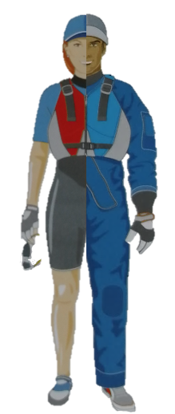

Summer |  | Winter
- Sun Hat / Bump Hat |  | - Warm Hat / Bump Hat
- Sunglasses |  | - Fleece / warm top
- Sunscreen |  | - Waterproof jacket
- Splash proof top |  | - Waterproof trousers, or
- Shorts, or |  | - Wet suit (winter), or
- Wet suit (shortie) |  | - Woolly bear &
- Rash vest |  | - Drysuit
- Buoyancy Aid |  | - Buoyancy Aid
- Whistle |  | - Whistle
- Gloves (fingerless) |  | - Gloves (full finger)
- Dinghy shoes / boots |  | - Dinghy shoes / boots
- Water bottle |  | - Water bottle
- Rations (biscuits) |  | - Rations (biscuits)
- Towel |  | - Towel
- Shower gel |  | - Shower gel
- Bag for wet things |  | - Bag for wet things
- Change of clothes |  | - Change of clothes
- String to keep prescription glasses on |  | - String to keep prescription glasses on
- Waterproof Watch (if racing) |  | - Waterproof Watch (if racing)
- Check Weather Forecast |  | - Check Weather Forecast

Expected arrival at Junior Saturday sessions from hh:mm to be ready to launch at hh:mm
The Grebe Club events are largely in the Clubhouse starting at 10am ready for 10:30

